- Start with ₹100,000 capital.
- Start with no shares.
- Keep running up to 375 minutes.
- Buy 1 share initially.
- If price is rising → keep holding.
- When price starts to fall → buy 2 more shares (average the cost).
- If total portfolio value shows 2% profit → sell all shares and stop.
- Stop automatically after 375 minutes, even if 2% profit is not achieved.

Worst case
Share Price start at 1000, Algo bought first share at 1000 and keep on averaging till stock down 7% - Max Capital at risk was -4.5%
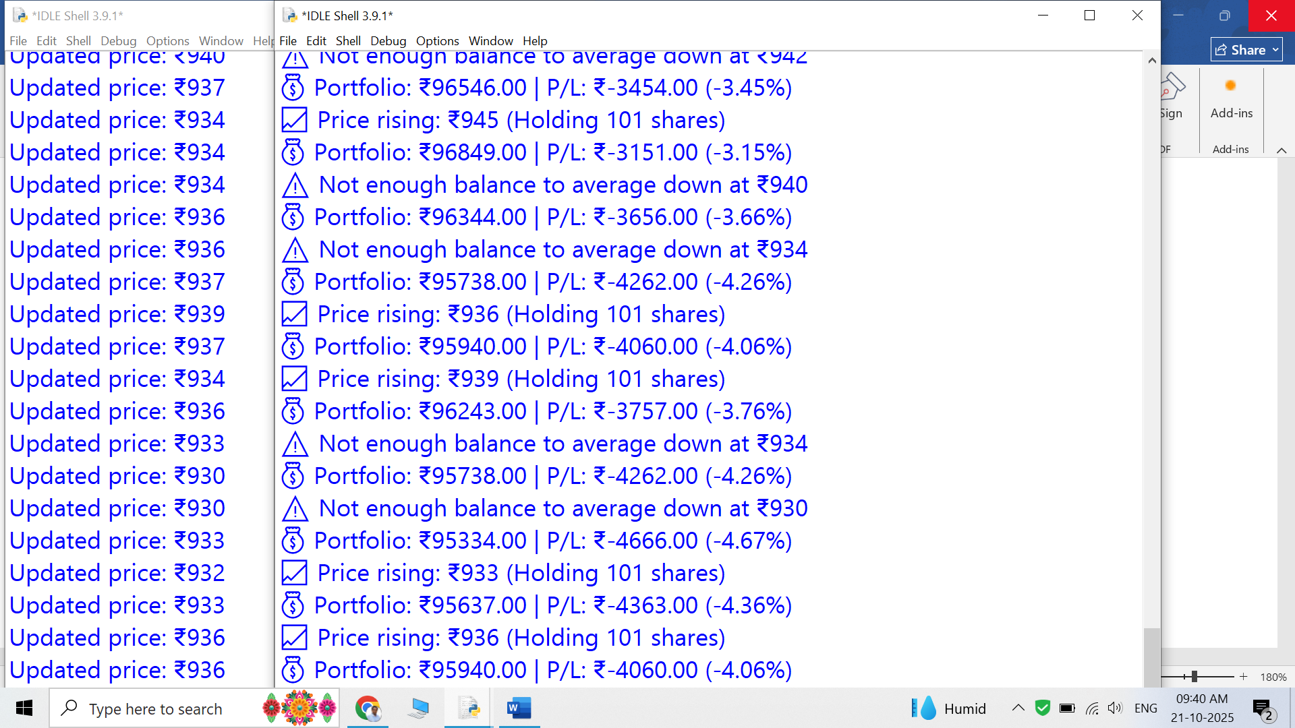
Stock Recover -3 % from -7 %, and PNL improve from -4.5% to -0.4%

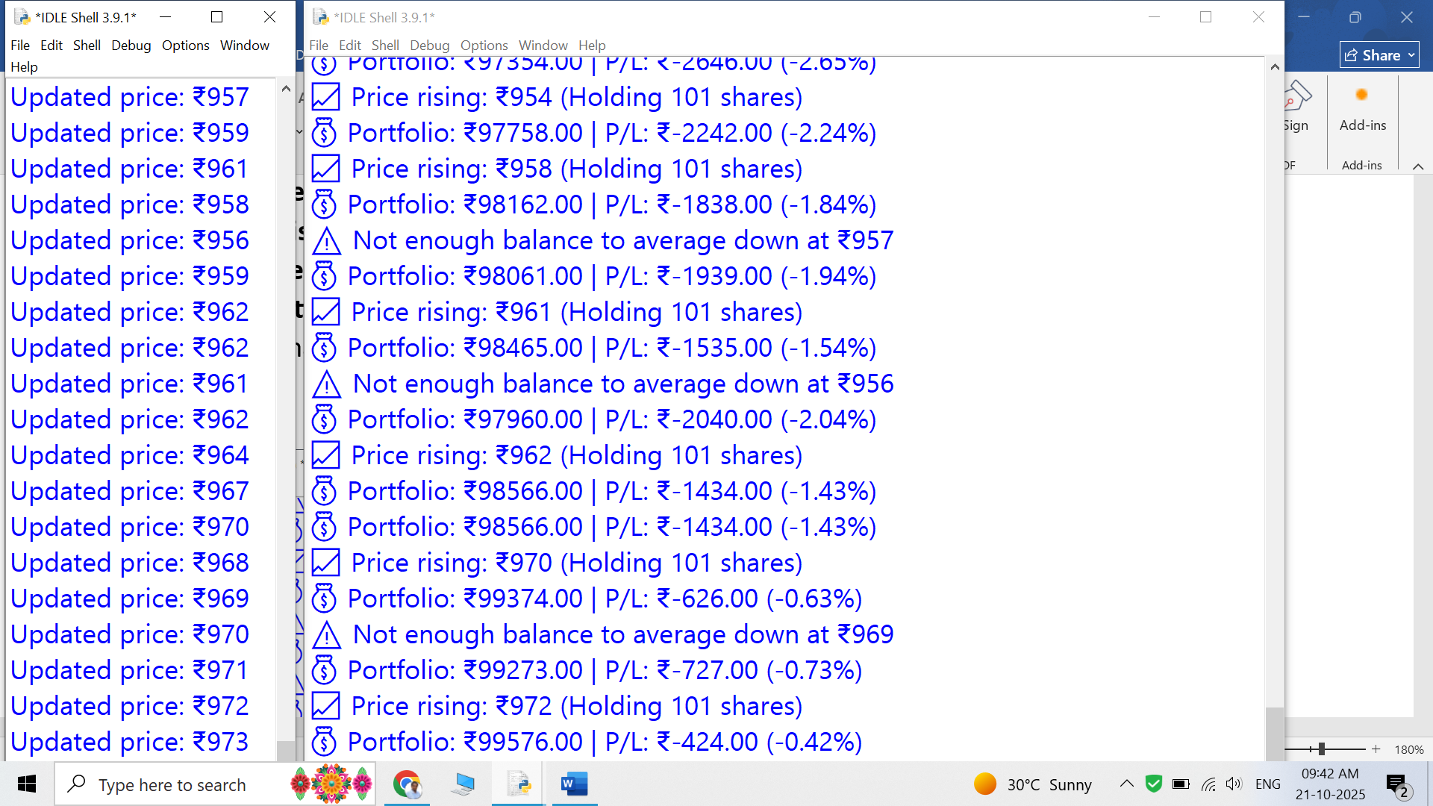

Stock Recover -1 % from -3 %, and PNL improve from 0.4% to 1.40%

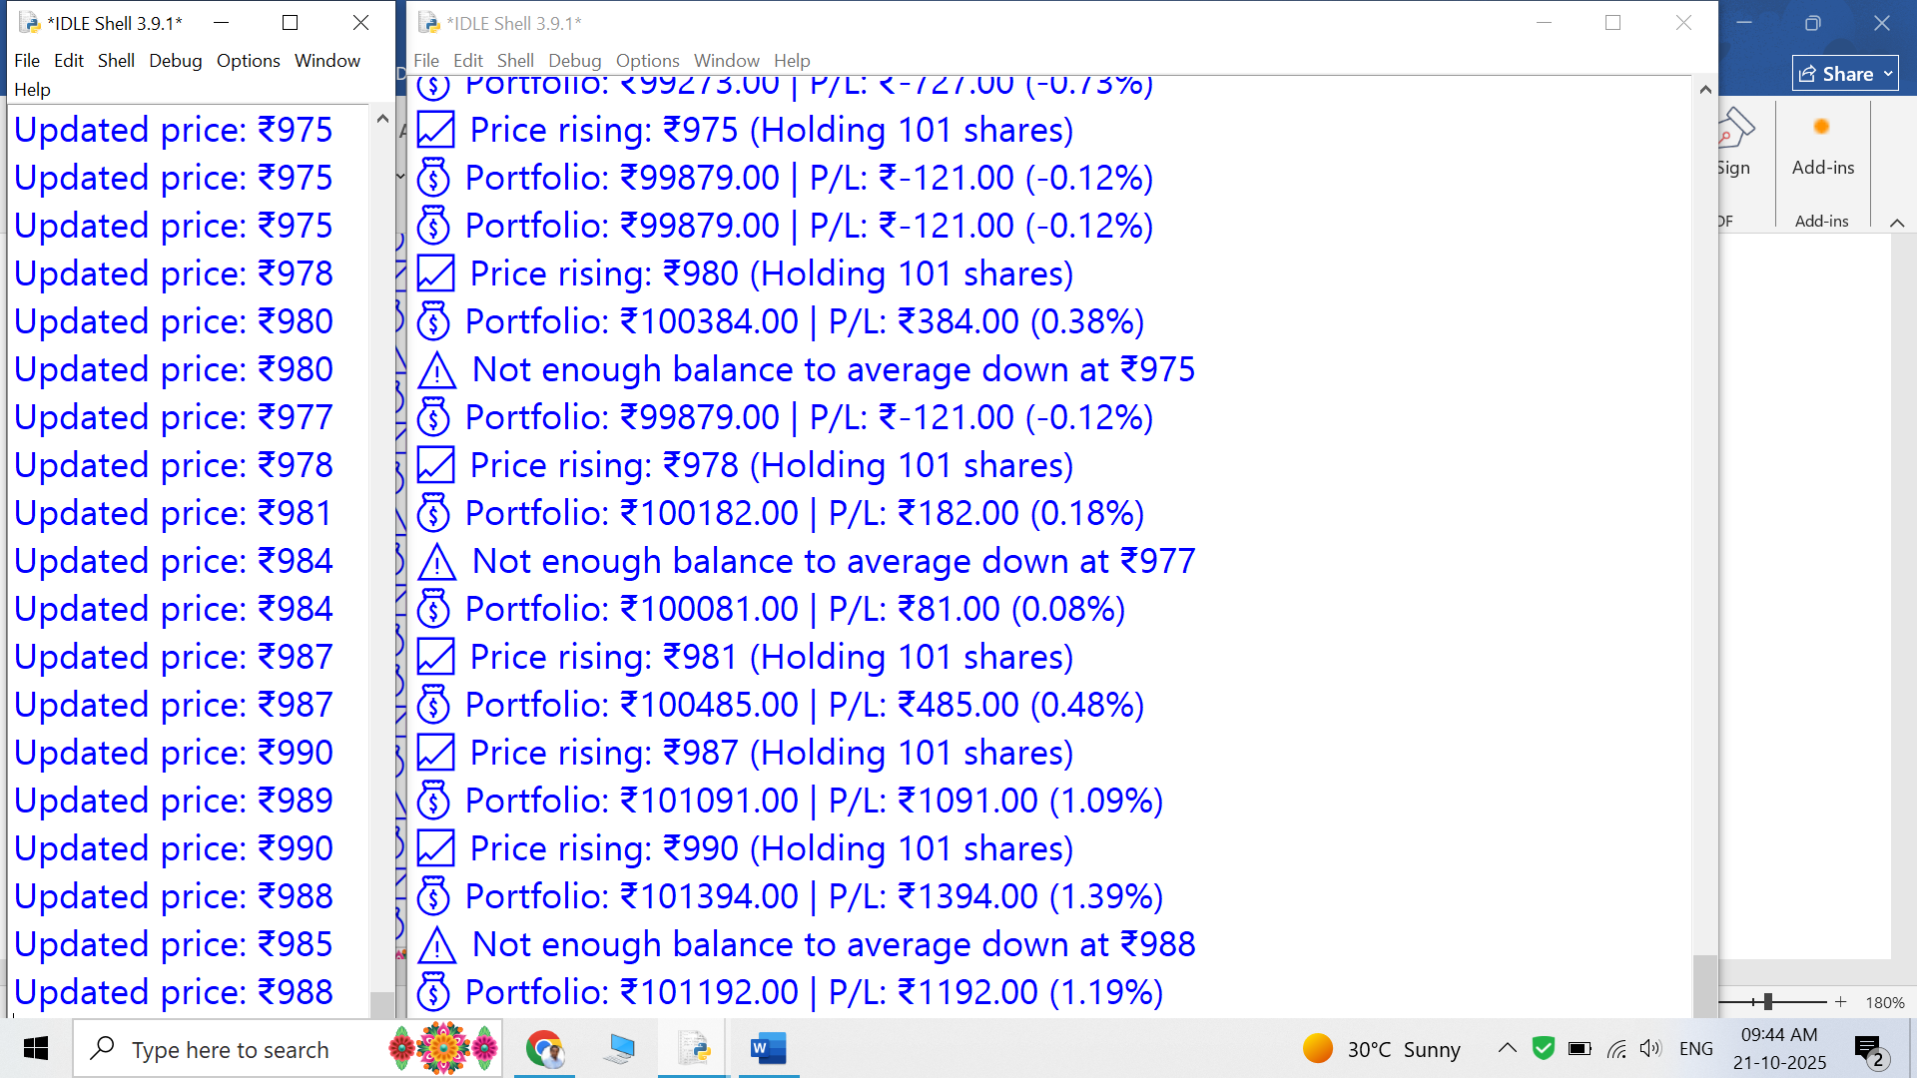

Stock Recover 0 % from -1 %, and PNL improve from 1.4% to 2%

